Course

Project Name: Restaurant menu application

Student Name

Professor

Date

Items

1. milk: cost $3.5
2. chocolate: cost $2.3
3. bread: cost $2.5
4. cocacola 500ml: cost $5.0
5. fish: cost $10.0
6. picana: cost $13.25
7. orange juice 1000ml: cost $8.0
8. crisps: cost $4.5
9. Chapati: cost $ 6.0
10. Samosa: cost $4.5

Decisions

1. Perform transaction?
2. Buy another product
3. Calculate cost
4. Quit program?
5. Product okay or choose another?

UML class diagram

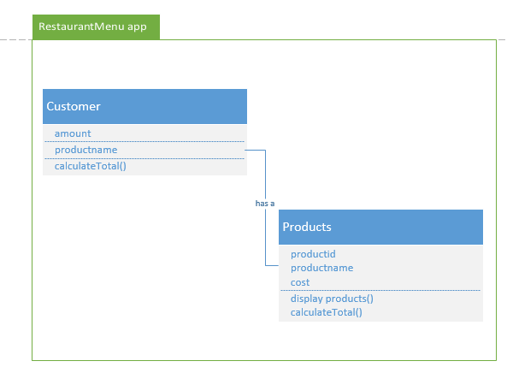

UML activity diagram

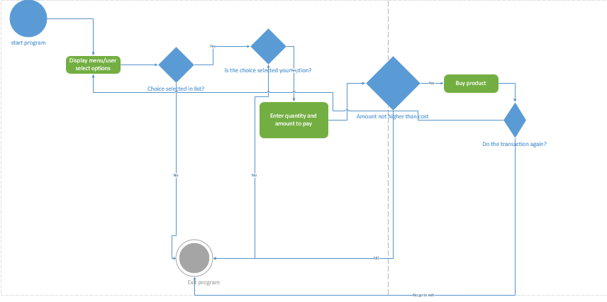

Project source code

/\*

\* To change this license header, choose License Headers in Project Properties.

\* To change this template file, choose Tools | Templates

\* and open the template in the editor.

\*/

package restaurantmenu;

import java.util.\*;

public class RestaurantMenu {

static Scanner sc= new Scanner(System.in);

public static void menu(){

int choice;

double cost;

double total=0;

int quantity;

int paid;

double bal = 0;

String opt;

String another;

System.out.println("\*\*\*\*\*\*\*\*\*\*\*\*\*\*\*\*\*\*\*\*\*\*\*\*\* MENU \*\*\*\*\*\*\*\*\*\*\*\*\*\*\*\*\*\*\*\*\*\*\*");

System.out.println("1 milk: cost $3.5 ");

System.out.println("2 chocolate: cost $2.3");

System.out.println("3 bread: cost $2.5");

System.out.println("4 cocacola 500ml: cost $5.0");

System.out.println("5 fish: cost $10.0");

System.out.println("6 picana: cost $13.25");

System.out.println("7 orange juice 1000ml: cost $8.0");

System.out.println("8 crisps: cost $4.5");

System.out.println("9 Chapati: cost $ 6.0");

System.out.println("10 Samosa: cost $4.5");

System.out.println("\*\*\*\*\*\*\*\*\*\*\*\*\*\*\*\*\*\*\*\*\*\*\*\*\*\*\*\*\*\*\*\*\*\*\*\*\*\*\*\*\*\*\*\*\*\*\*\*\*\*\*\*\*\*");

restart: for(int i=0; i<20; i++){

do{

System.out.println("Select your meal using the numbers: ");

choice=sc.nextInt();

}while(choice !=1 && choice !=2 && choice !=3 && choice !=4

&& choice !=5 && choice !=6 && choice !=7 && choice

!=8 && choice !=9 && choice !=10);

if(choice == 1){

System.out.println("You selected milk continue? y / n");

opt = sc.next();

if(Objects.equals(opt, "y")){

System.out.println("Enter the quantity");

quantity = sc.nextInt();

System.out.println("Enter Amount to pay: ");

paid = sc.nextInt();

cost= 3.5\*quantity;

total += cost;

if(cost > paid){

System.out.println("Sorry you have insufficient funds. Total cost is $ " + cost);

System.exit(1);

}else{

bal = (double)(paid - cost);

System.out.println("Total cost is: "+ cost + "\nYour bal is : " + String.format( "%.2f", bal ));

System.out.println("Do you want to purchase another good? y / n");

another = sc.next();

if(Objects.equals(another, "y")){

continue restart;

}else{

System.out.println("Thanks working with us! welcome again!");

System.exit(0);

}

}

}else{

System.out.println("Transaction cancelled. Thanks!");

System.exit(0);

}

}else if(choice == 2){

System.out.println("You selected Chocolate continue? y / n");

opt = sc.next();

if(Objects.equals(opt, "y")){

System.out.println("Enter the quantity");

quantity = sc.nextInt();

System.out.println("Enter Amount to pay: ");

paid = sc.nextInt();

cost= 2.3\*quantity;

if(cost > paid){

System.out.println("Sorry you have insufficient funds. Total cost is $ " + cost);

System.exit(1);

}else{

bal = (double)(paid - cost);

System.out.println("Total cost is: "+ cost + "\nYour bal is : " + String.format( "%.2f", bal ));

System.out.println("Do you want to purchase another good? y / n");

another = sc.next();

if(Objects.equals(another, "y")){

continue restart;

}else{

System.out.println("Thanks working with us! welcome again!");

System.exit(0);

}

}

}else{

System.out.println("Transaction cancelled. Thanks!");

System.exit(0);

}

}else if(choice == 3){

System.out.println("You selected bread continue? y / n");

opt = sc.next();

if(Objects.equals(opt, "y")){

System.out.println("Enter the quantity");

quantity = sc.nextInt();

System.out.println("Enter Amount to pay: ");

paid = sc.nextInt();

cost= 2.5\*quantity;

if(cost > paid){

System.out.println("Sorry you have insufficient funds. Total cost is $ " + cost);

System.exit(1);

}else{

bal = (double)(paid - cost);

System.out.println("Total cost is: "+ cost + "\nYour bal is : " + String.format( "%.2f", bal ));

System.out.println("Do you want to purchase another good? y / n");

another = sc.next();

if(Objects.equals(another, "y")){

continue restart;

}else{

System.out.println("Thanks working with us! welcome again!");

System.exit(0);

}

}

}else{

System.out.println("Transaction cancelled. Thanks!");

System.exit(0);

}

}else if(choice == 4){

System.out.println("You selected Cocacola continue? y / n");

opt = sc.next();

if(Objects.equals(opt, "y")){

System.out.println("Enter the quantity");

quantity = sc.nextInt();

System.out.println("Enter Amount to pay: ");

paid = sc.nextInt();

cost= 5.0\*quantity;

if(cost > paid){

System.out.println("Sorry you have insufficient funds. Total cost is $ " + cost);

System.exit(1);

}else{

bal = (double)(paid - cost);

System.out.println("Total cost is: "+ cost + "\nYour bal is : " + String.format( "%.2f", bal ));

System.out.println("Do you want to purchase another good? y / n");

another = sc.next();

if(Objects.equals(another, "y")){

continue restart;

}else{

System.out.println("Thanks working with us! welcome again!");

System.exit(0);

}

}

}else{

System.out.println("Transaction cancelled. Thanks!");

System.exit(0);

}

}else if(choice == 5){

System.out.println("You selected Fish continue? y / n");

opt = sc.next();

if(Objects.equals(opt, "y")){

System.out.println("Enter the quantity");

quantity = sc.nextInt();

System.out.println("Enter Amount to pay: ");

paid = sc.nextInt();

cost= 10.0\*quantity;

if(cost > paid){

System.out.println("Sorry you have insufficient funds. Total cost is $ " + cost);

System.exit(1);

}else{

bal = (double)(paid - cost);

System.out.println("Total cost is: "+ cost + "\nYour bal is : " + String.format( "%.2f", bal ));

System.out.println("Do you want to purchase another good? y / n");

another = sc.next();

if(Objects.equals(another, "y")){

continue restart;

}else{

System.out.println("Thanks working with us! welcome again!");

System.exit(0);

}

}

}else{

System.out.println("Transaction cancelled. Thanks!");

System.exit(0);

}

}else if(choice == 6){

System.out.println("You selected Picana continue? y / n");

opt = sc.next();

if(Objects.equals(opt, "y")){

System.out.println("Enter the quantity");

quantity = sc.nextInt();

System.out.println("Enter Amount to pay: ");

paid = sc.nextInt();

cost= 13.25\*quantity;

if(cost > paid){

System.out.println("Sorry you have insufficient funds. Total cost is $ " + cost);

System.exit(1);

}else{

bal = (double)(paid - cost);

System.out.println("Total cost is: "+ cost + "\nYour bal is : " + String.format( "%.2f", bal ));

System.out.println("Do you want to purchase another good? y / n");

another = sc.next();

if(Objects.equals(another, "y")){

continue restart;

}else{

System.out.println("Thanks working with us! welcome again!");

System.exit(0);

}

}

}else{

System.out.println("Transaction cancelled. Thanks!");

System.exit(0);

}

}else if(choice == 7){

System.out.println("You selected Orange Juice continue? y / n");

opt = sc.next();

if(Objects.equals(opt, "y")){

System.out.println("Enter the quantity");

quantity = sc.nextInt();

System.out.println("Enter Amount to pay: ");

paid = sc.nextInt();

cost= 8.0\*quantity;

if(cost > paid){

System.out.println("Sorry you have insufficient funds. Total cost is $ " + cost);

System.exit(1);

}else{

bal = (double)(paid - cost);

System.out.println("Total cost is: "+ cost + "\nYour bal is : " + String.format( "%.2f", bal ));

System.out.println("Do you want to purchase another good? y / n");

another = sc.next();

if(Objects.equals(another, "y")){

continue restart;

}else{

System.out.println("Thanks working with us! welcome again!");

System.exit(0);

}

}

}else{

System.out.println("Transaction cancelled. Thanks!");

System.exit(0);

}

}else if(choice == 8){

System.out.println("You selected Crisps continue? y / n");

opt = sc.next();

if(Objects.equals(opt, "y")){

System.out.println("Enter the quantity");

quantity = sc.nextInt();

System.out.println("Enter Amount to pay: ");

paid = sc.nextInt();

cost= 4.0\*quantity;

if(cost > paid){

System.out.println("Sorry you have insufficient funds. Total cost is $ " + cost);

System.exit(1);

}else{

bal = (double)(paid - cost);

System.out.println("Total cost is: "+ cost + "\nYour bal is : " + String.format( "%.2f", bal ));

System.out.println("Do you want to purchase another good? y / n");

another = sc.next();

if(Objects.equals(another, "y")){

continue restart;

}else{

System.out.println("Thanks working with us! welcome again!");

System.exit(0);

}

}

}else{

System.out.println("Transaction cancelled. Thanks!");

System.exit(0);

}

}else if(choice == 9){

System.out.println("You selected Chapati continue? y / n");

opt = sc.next();

if(Objects.equals(opt, "y")){

System.out.println("Enter the quantity");

quantity = sc.nextInt();

System.out.println("Enter Amount to pay: ");

paid = sc.nextInt();

cost= 6.0\*quantity;

if(cost > paid){

System.out.println("Sorry you have insufficient funds. Total cost is $ " + cost);

System.exit(1);

}else{

bal = (double)(paid - cost);

System.out.println("Total cost is: "+ cost + "\nYour bal is : " + String.format( "%.2f", bal ));

System.out.println("Do you want to purchase another good? y / n");

another = sc.next();

if(Objects.equals(another, "y")){

continue restart;

}else{

System.out.println("Thanks working with us! welcome again!");

System.exit(0);

}

}

}else{

System.out.println("Transaction cancelled. Thanks!");

System.exit(0);

}

}else if(choice == 10){

System.out.println("You selected Samosa continue? y / n");

opt = sc.next();

if(Objects.equals(opt, "y")){

System.out.println("Enter the quantity");

quantity = sc.nextInt();

System.out.println("Enter Amount to pay: ");

paid = sc.nextInt();

cost= 4.5\*quantity;

if(cost > paid){

System.out.println("Sorry you have insufficient funds. Total cost is $ " + cost);

System.exit(1);

}else{

bal = (double)(paid - cost);

System.out.println("Total cost is: "+ cost + "\nYour bal is : " + String.format( "%.2f", bal ));

System.out.println("Do you want to purchase another good? y / n");

another = sc.next();

if(Objects.equals(another, "y")){

continue restart;

}else{

System.out.println("Thanks working with us! welcome again!");

System.exit(0);

}

}

}else{

System.out.println("Transaction cancelled. Thanks!");

System.exit(0);

}

}else{

System.out.println("Hey, enter number fitting from the menu list. Try again");

System.exit(0);

}

}

}

public static void main(String[] args) {

RestaurantMenu obj = new RestaurantMenu();

obj.menu();

}

}

Outputs

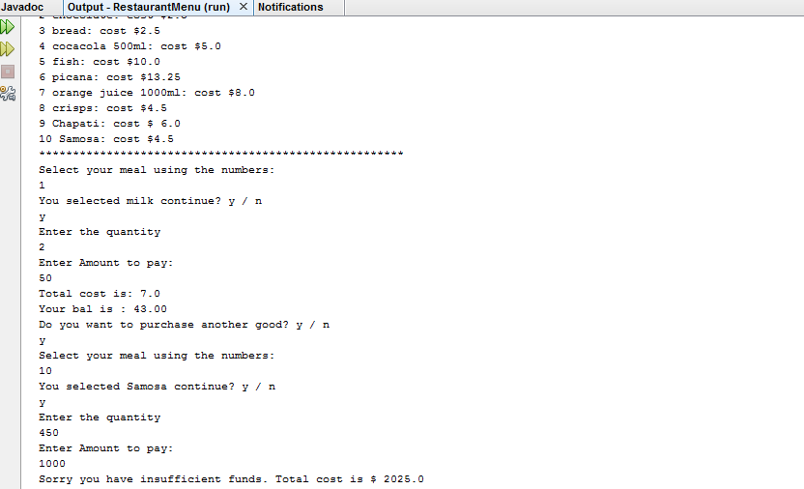

Importance of object modeling in object oriented programming

Object modeling has the following main advantages in object oriented programming and software development:-

* Modeling offers high level abstraction which help in developing a conceptual framework to help solve the problem at hand.
* Helps in reusing of the results of the output program since there are stable abstractions.
* It reduces complexity of the program being developed
* Helps establish relationship between entities and attributes of the system being developed.
* Helps in presenting the reality of the program

References

Principles of Object-Oriented Software development. (n.d). available at http://www.cs.vu.nl/~eliens/oop/1-3.html